Published 17 Nov 2020 Tel: +44 (0) 1865 339370
Email: info@pamsteele.co.uk

3,121 Days in the Driving Seat of the National Medical Supplies Fund: Lessons to be Shared for Future Application
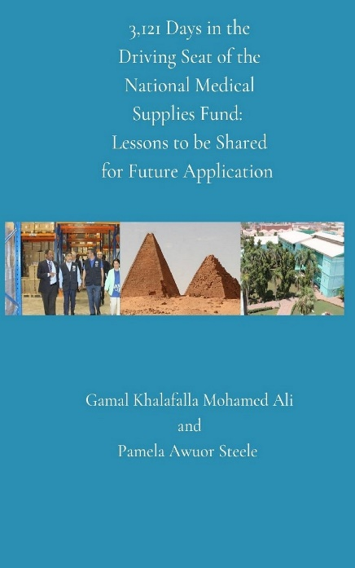
Including real-life examples and expert recommendations for successful supply chain transformation, Dr Gamal Khalafalla Mohamed Ali’s new book, 3,121 Days in the Driving Seat of the National Medical Supplies Fund: Lessons to be Shared for Future Application documents the author’s experience as the former Director General of the National Medical Supplies Fund (NMSF) in Sudan.
Co-authored by Pamela Steele and with contributions from leading supply chain experts, this helpful new title provides a roadmap for supply chain leaders aiming to improve medical supplies agencies and systems and therefore is essential reading for those working to achieve more efficient and effective health supply chains that are also financially self-sustaining. It also covers topics that are fundamental for supply chain transformation, including the role of leadership, human resources and automation, as well as specific initiatives Dr Mohamed Ali undertook to foster the NMSF's growth.
‘As a former NMSF leader, I realised the challenge of getting medicine and other health products to people, especially in remote areas,’ said Dr Mohamed Ali. ‘I also found a significant gap in the literature around successful transformation of public supply chains for health products. This book departs from theory and provides empirical lessons to help others achieve successful transformation programmes.’
3,121 Days in the Driving Seat of the National Medical Supplies Fund offers the unique opportunity to learn from Dr Mohamed Ali's vast experience as a key architect in the NMSF's transformation. Order your copy now.

Pamela Steele Associates (PSA) specialises in Supply Chain Transformation for Public Health and Humanitarian sectors through consultancy, research and training.
If you would like more information on the book’s release, please contact info@pamsteele.co.uk.

